WESTERN STATES CONFERENCE 2024
PRESENTATION FILE UPLOAD INSTRUCTIONS

The deadline for file uploading is Monday, May 13th, 5pm PDT.
- If your file is not successfully uploaded by this deadline, you will be making your presentation without slides.
- Make sure you plan ahead, and follow the PowerPoint Guidelines (available on the WSC web site).
- Your file should be named presentation#lastname.pptx, i.e. 255Bestresidentever.pptx
- Files named incorrectly, containing unacceptable elements (embedded files, hyperlinks, non-standard fonts), or saved in an inappropriate format will be rejected and deleted from the upload site.
- Once your file is uploaded the file will be locked, and it cannot be altered.
- See separate instructions below for using Excel charts and graphs below.

- Make sure you plan ahead, and follow the PowerPoint presentation checklist and the instructions for recording and saving your narrated PowerPoint presentation (both available on the WSC web site). Save your video file at the lowest resolution (480p) to keep the file size as small as possible.
- Files named incorrectly (presentation#lastname.mp4, i.e. 220Katz.mp4), and saved in an another file format will be rejected and deleted from the upload site.
- Do not wait until the last minute to upload. If everyone tries to upload at the same time, the capacity of the site could be exceeded. Plan ahead!
- Once your file is uploaded the file will be transferred to a different site, so any subsequent uploads will not be used. UPLOAD ONE FINAL FILE.

ALL Residents’ and Fellows’ presentation files must be uploaded to a central web site.

If you follow these instructions, uploading your PowerPoint (.ppt or .pptx; other file formats such a .pdf will be rejected) presentation file will be easy and take only a couple of minutes. If something is not working, before you ask for help, READ THE INSTRUCTIONS! If you still need help, contact mdkatz@arizona.edu.

Before you start, make sure you know the name of your assigned presentation room and session (e.g. Mon AM, Tues PM).

All files will be uploaded to a SharePoint folder named Western States Conference 2024.

Make sure that the file you upload is your final preceptor- approved version. FINAL means FINAL!

To access the folder from your computer (Windows or Mac) click on:

Western States Conference 2024

You should then see a list of folders for each presentation room (list of files in the folder will vary):
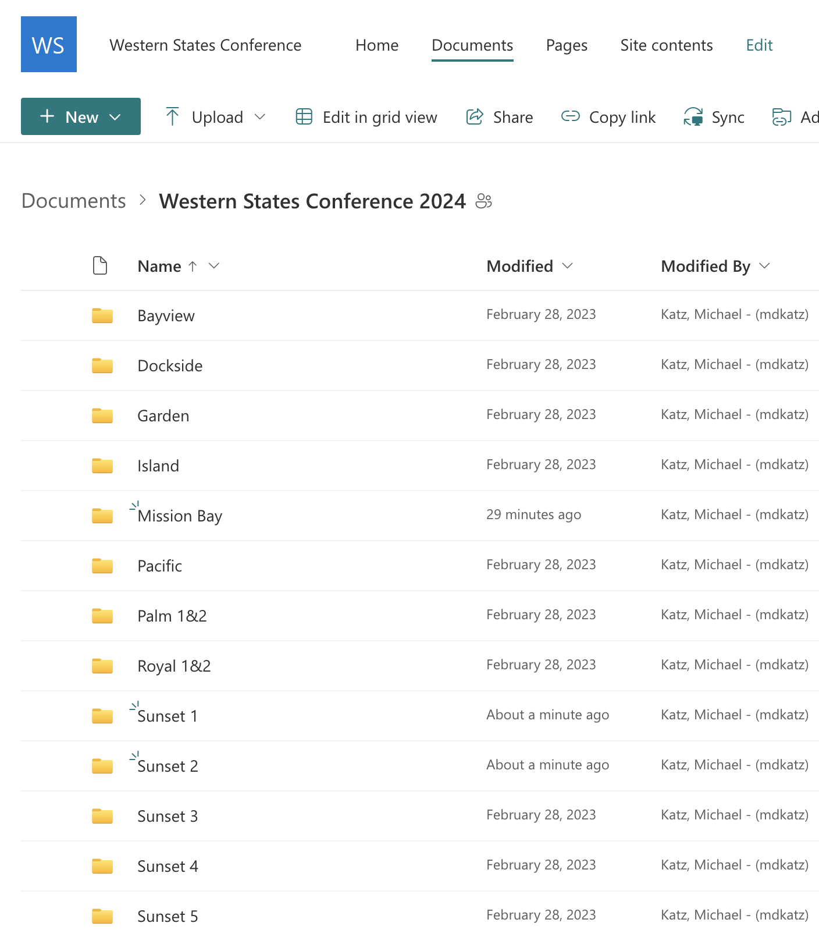

Then, click on the folder for your assigned presentation room, and you will see
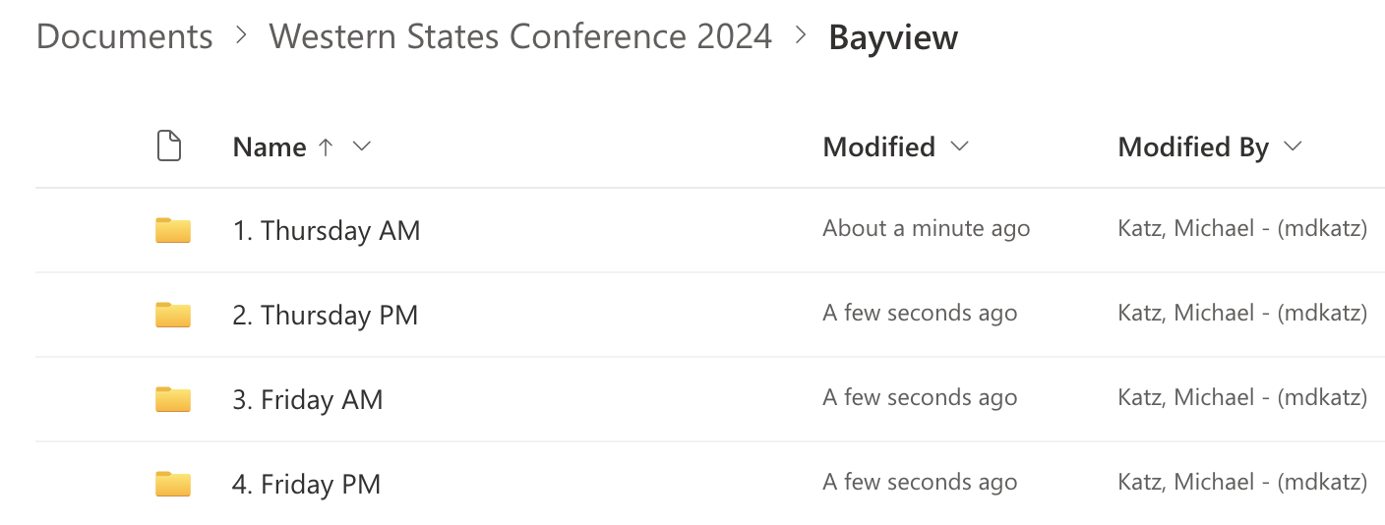

Then, click on your assigned presentation session (Thursday or Friday, morning or afternoon)
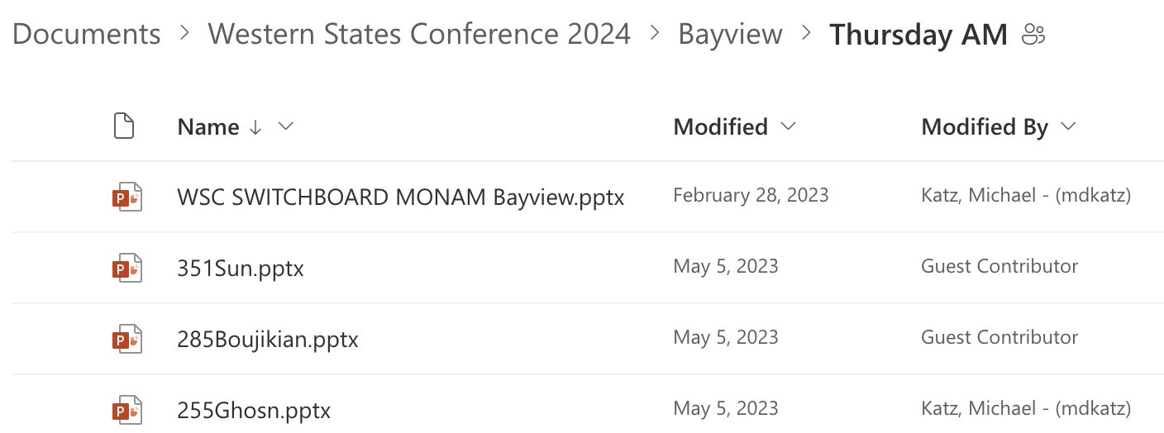
The easiest way to upload your file is to simply drag and drop in into the window

If drag and drop doesn’t work, click on Upload at the top left of page, click on Files and choose your file to upload. The time it takes to upload will depend on the file size and speed of your internet service.

Once the file is uploaded, you should see it listed.
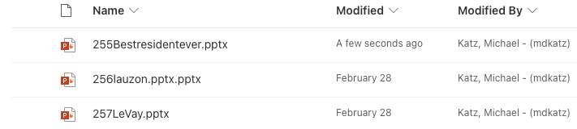

SUCCESS!! While not necessary, feel free to click on your file to make sure it opens. You will not receive any separate notification of your upload. If you see your file in the SharePoint folder, you are good to go!

When you actually do this, make sure you select and upload to YOUR assigned presentation room and session folder

